GTB  
  
**QA**  
[DEV 20.12] OT-814 | AA | DE | HP | HPR Range Personalisation | Hybrid & Electric – 3 April 2020

**Jira ticket:**  
<https://jira.uhub.biz/browse/GTBEMEAOPT-814>

**Site**  
<https://www.ford.de/>

**Test location**  
Homepage Rotation

**Tags**

CONTROL - tt:nwp:opt-814:ab:hp:hpr-hybrid-electric:control

CHALLENGER B - tt:nwp:opt-814:ab:hp:hpr-hybrid-electric:var-b

CHALLENGER C - tt:nwp:opt-814:ab:hp:hpr-hybrid-electric:var-c

**Hypothesis**  
The results for the most recent round of personalisation highlights that there is an opportunity to try a new approach on the homepage. Indeed, the previous round of testing, which retargeted with a single-vehicle personalised HPR for audiences such as NPP Visits, BP-A, BP-C, TDR-A, TDR-C, KMI-A, KMI-C and BRD, produced the following results.

For User Case #1, we see higher HPR CTR for people who see default content (control has on avg +104% CTR). Across 3x markets, people who are taken back to NPP are more likely to become BP-C and have +26.2% higher BP-C. This audience is still in “discover” mode: they don’t want to be stuck into a one-vehicle journey. The fact people who go back to NPP have higher BP-C CR% shows HP might not be the hottest page for BP-C. We should keep targeting this audience on HP, but we should move away from one-vehicle strategies and test showing vehicle range instead (eg SUV).

For the other User Cases, we see higher HPR CTR for people who see default content (control has on avg +166% CTR). Across 3x markets, people who are taken back to NPP are more likely to become BP-C and have +26.4% higher BP-C. BP-A could be BP-C, which is indicated by the fact that people are +56% more likely to click on default than the BP slide. The fact people who go back to NPP have higher BP-C CR% shows NPP could be better page. We should target BP Abandons on the NPP, where we could exploit the billboard but also other components and their order on the page; we can keep testing this audience on HP as well but using a ‘range’ strategy.

**Test Description**  
  
**ACTIONS:** These are the actions you can take in order to ‘trigger’ the homepage change. You only need to do one of the actions in order to ‘trigger’ the change on the homepage.  
Visiting the Nameplate Page of one of the following vehicles: Der Neue Ford Puma, Der Neue Ford Kuga, Der Neue Ford Mustang Mach-E, Ford Mondeo, Der Neue Ford Explorer Plug-in Hybrid, Ford Tourneo Custom and Ford Transit Custom Nugget. The easiest way to do this is from the home page mouse over “Modelle” in any of the sub options look for one of the above cars and click on them. You are now on the Nameplate Page.

Abandoning a Build and Price for one of the following vehicles: Der Neue Ford Puma, Der Neue Ford Kuga, Ford Mondeo, Der Neue Ford Explorer Plug-in Hybrid. To do these click on the “Konfigurator” link at the top of the page. On the new page select one of the above cars to configure. And then once on this page navigate away from this page. You have now abandoned a Build and Price.

Complete a Build and Price for one of the following vehicles: Der Neue Ford Puma, Der Neue Ford Kuga, Ford Mondeo, Der Neue Ford Explorer Plug-in Hybrid. To do these click on the “Konfigurator” link at the top of the page. On the new page select one of the above cars to configure. And then once on this page click on the blue button on the right that says “Zusammenfassung & nächste Schritte”. You have now completed a Build and Price.

Abandon a Test Drive Request for one of the following vehicles: Der Neue Ford Puma, Ford Mondeo, Ford Tourneo Custom. The easiest way to do these is to click on the “Probefahrt” link at the top of the page on the right. Once on this page click on the “Formular” button, It’s the 3rd option. Now select one of the above vehicles and click on the button at the bottom named “Weiter”. Now navigate away from this page. You have now abandoned a test drive request.

Requesting a Brochure for one of the following vehicles: Der Neue Ford Puma, Der Neue Ford Kuga, Ford Mondeo, Der Neue Ford Explorer Plug-in Hybrid, Ford Transit Custom Nugget. To this click on the link at the top of the screen, on the mini header that says “Schnellsuche”. Then in the drop down select “Broschüren, Preise, Daten”. Now on this page click on any of the above cars. You have now requested a brochure.

Abandoning a Build and Price for Der Neue Ford Mustang Mach-E. To do this, visit the Nameplate Page for the mentioned vehicle. Click on either the “RESERVIEREN” button on blue header right of the “Newsletter” button or click on the “JETZT RESERVIEREN” button which is next to the stats. Once on this page, navigate away from this page. You have now abandoned a Build and Price for Der Neue Ford Mustang Mach-E.

Complete a Build and Price for Der Neue Ford Mustang Mach-E. To do this, visit the Nameplate Page for the mentioned vehicle. Click on either the “RESERVIEREN” button on blue header right of the “Newsletter” button or click on the “JETZT RESERVIEREN” button which is next to the stats. Once on this page click on the “KONFI- GURIEREN” button and continue through all the steps until you get to a page that looks like the below. Once you’re on it, you have completed a build and price for Der Neue Ford Mustang Mach-E.

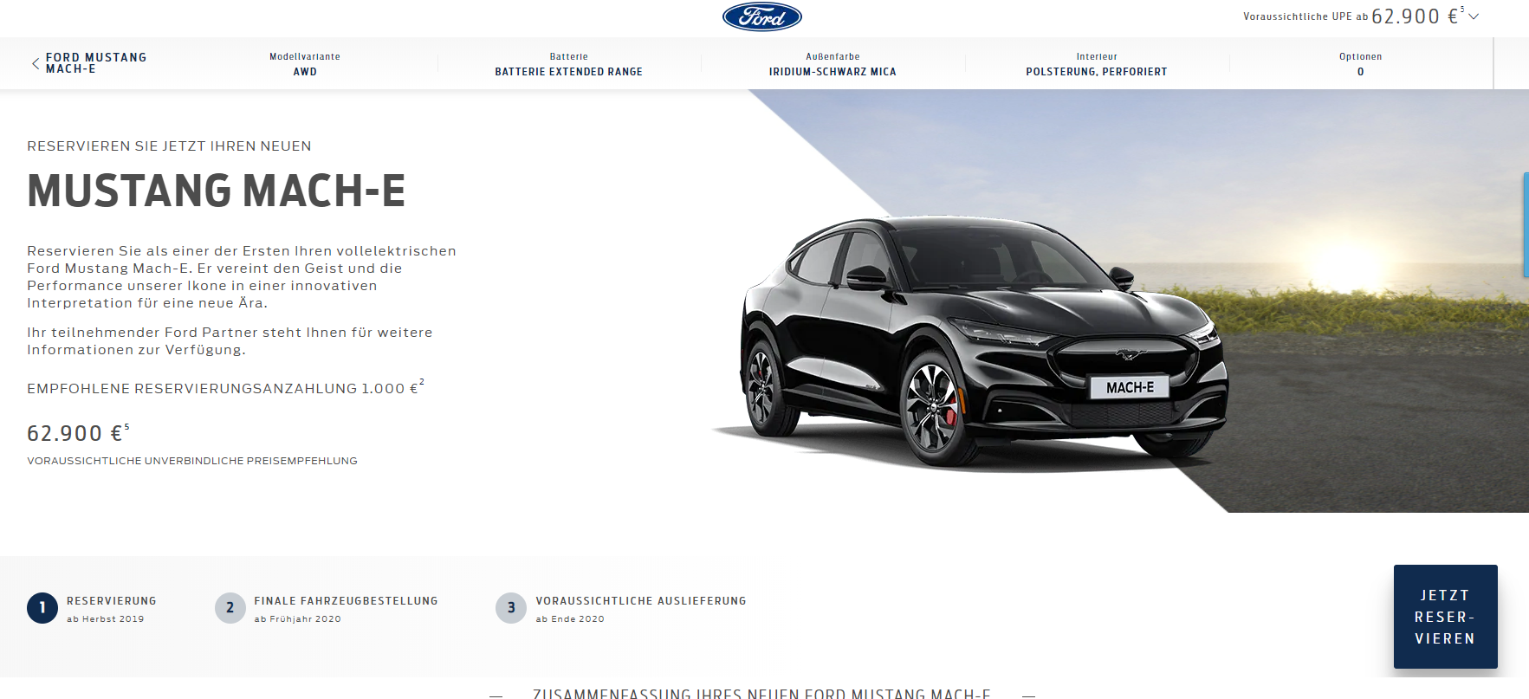

Keep Me Informed Abandoned for Der Neue Ford Mustang Mach-E. To do this, visit the Nameplate page for the mentioned vehicle. Click on the “Newsletter” button, it is to the left of the “RESERVIEREN” button. Once one the next page navigate to another page. You have now abandoned the Keep Me Informed action for Der Neue Ford Mustang Mach-E.

Keep Me Informed Completed for Der Neue Ford Mustang Mach-E. To do this, visit the Nameplate page for the mentioned vehicle. Click on the “Newsletter” button, it is to the left of the “RESERVIEREN” button. Enter all the details on the next page and click on the “Absenden” button at the bottom. Once you get to the next page you have completed the Keep Me Informed action for Der Neue Ford Mustang Mach-E.

Keep Me Informed Abandoned for Der Neue Ford Kuga. To do this, visit the Nameplate page for the mentioned vehicle. Click on the “Newsletter” button, it is on the top right of the page. Once the popup appears, navigate to another page. You have now abandoned the Keep Me Informed action for Der Neue Ford Kuga.

Keep Me Informed Completed for Der Neue Ford Kuga. To do this, visit the Nameplate page for the mentioned vehicle. Click on the “Newsletter” button, it is on the top right of the page. Once the popup appears, select the “Ford Newsletter” option and click on the “Weiter” button. Next fill in your information and click on the “Absenden” button to continue. You have now completed the Keep Me Informed action for Der Neue Ford Kuga.

**RULES:** When an action has been taken and the image is updated. The image would be seen a maximum of 3 times. After which it will no longer display, unless one of the actions are taken again. Taking an action resets the counter on the number of times you’ve seen the billboard. In other words, if you do the action go to home page view it twice and then do another action, you’ll see it 3 more times. Unless you do another action again.

**CHALLENGER B:** View the CHALLENGER B link. Do one of the mentioned **ACTIONS**. Return to the homepage. The first image in the billboard should be the below:

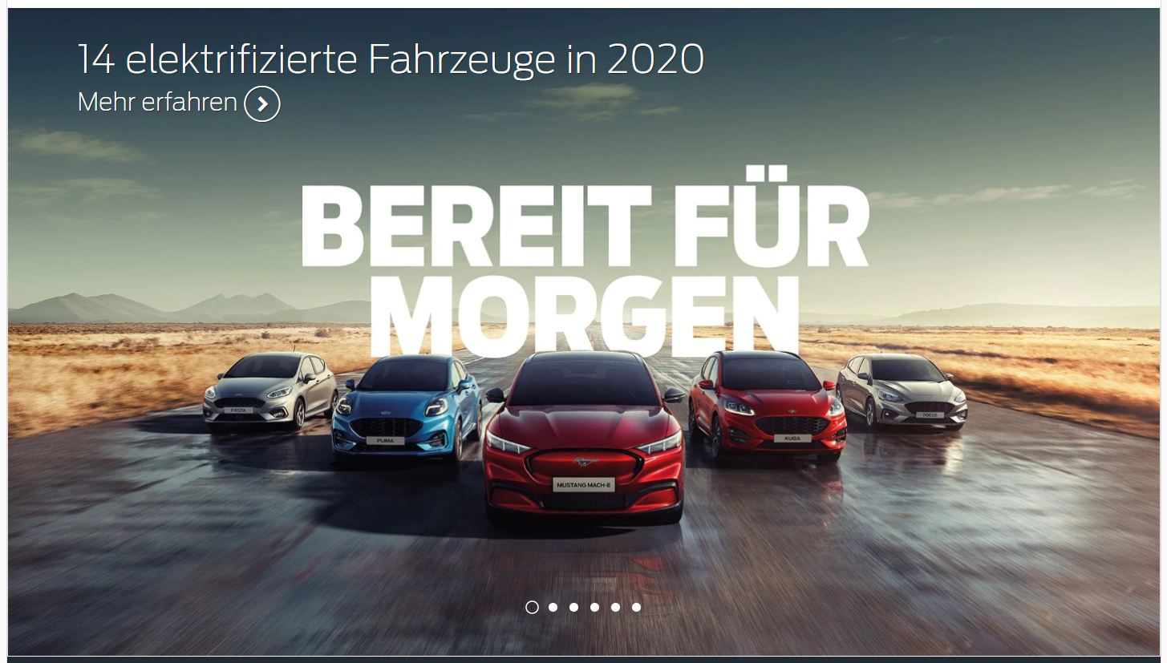

When you click on the billboard, it should take you to: <https://www.ford.de/kaufberatung/informieren/hybrid-elektrofahrzeuge>

**CHALLENGER C:** View the CHALLENGER C link. Do one of the mentioned ACTIONS. Return to the homepage. The first image in the billboard should be the below:  
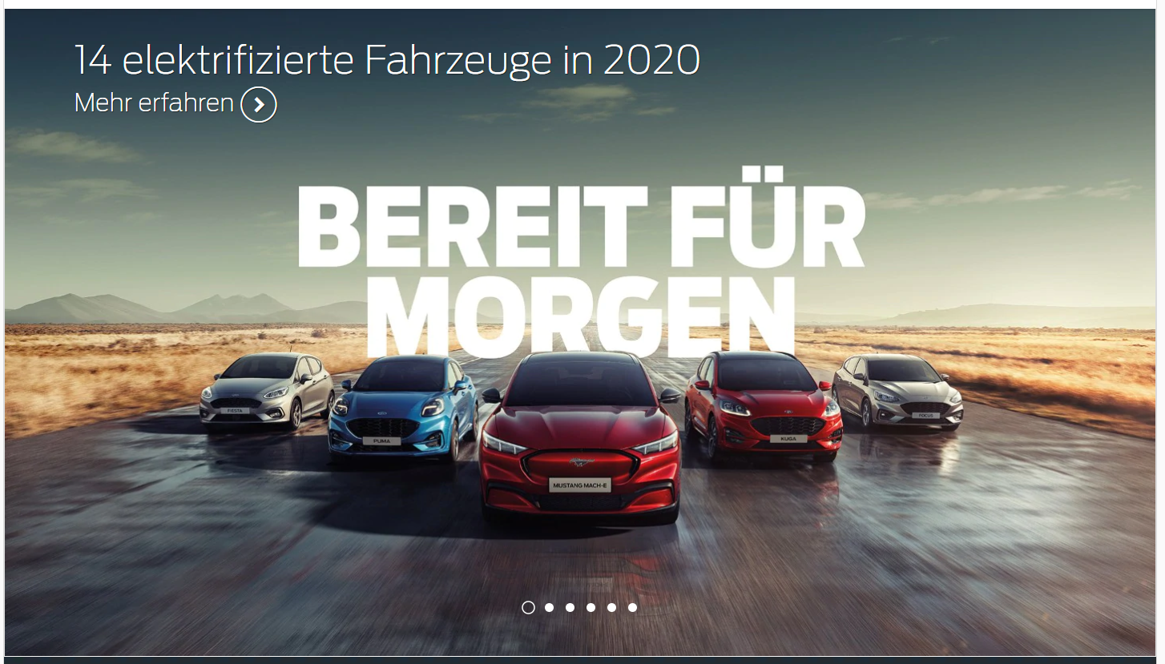When you click on the billboard, it should take you to:  
<https://www.ford.de/fahrzeuge>

**Browser:**   
All  
  
**Device:**   
All  
  
**Audience rules:**   
NPP Visits, BP-A, BP-C, TDR-A, KMI-A, KMI-C and BRD who come back to HP

**QA Links:**

**CONTROL:**

<https://www.ford.de/?at_preview_token=IV2vIvlLBu87RUthi6Osug%3D%3D&at_preview_index=1_1&at_preview_listed_activities_only=true>

**CHALLENGER B:**

<https://www.ford.de/?at_preview_token=IV2vIvlLBu87RUthi6Osug%3D%3D&at_preview_index=1_2&at_preview_listed_activities_only=true>

**CHALLENGER C:**

<https://www.ford.de/?at_preview_token=IV2vIvlLBu87RUthi6Osug%3D%3D&at_preview_index=1_3&at_preview_listed_activities_only=true>